ASSIGNMENT 3.1

Name:M.likhith Sai
Hallticket:2303a51026

Task1
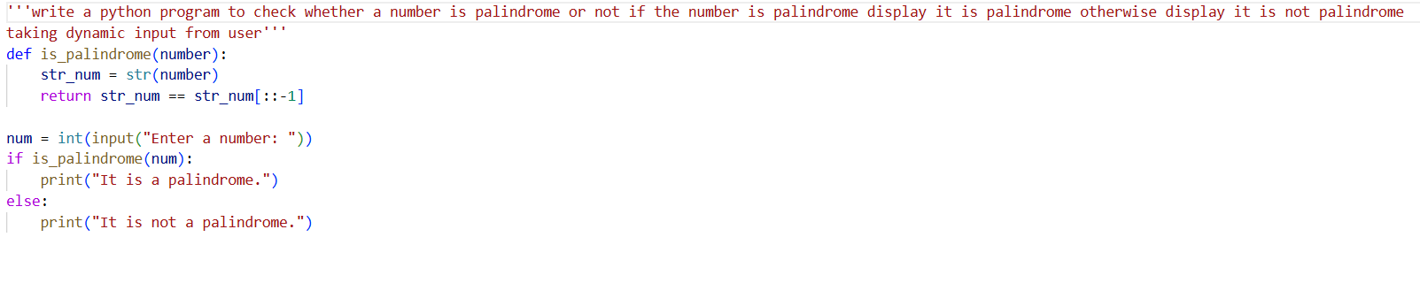
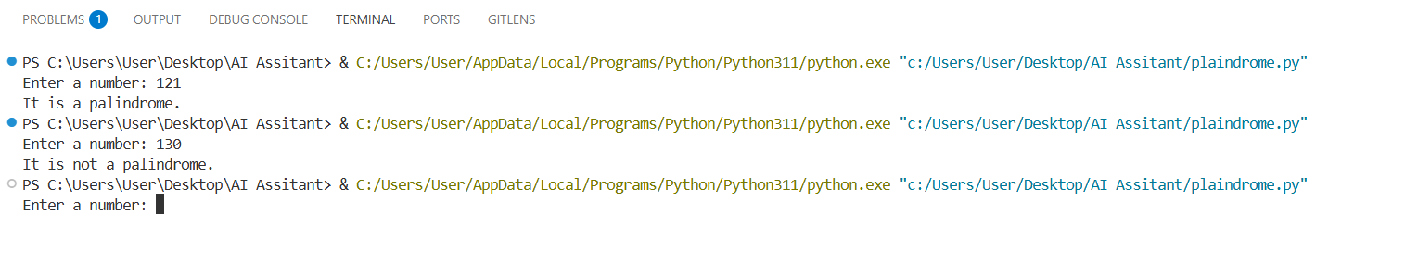
Task2
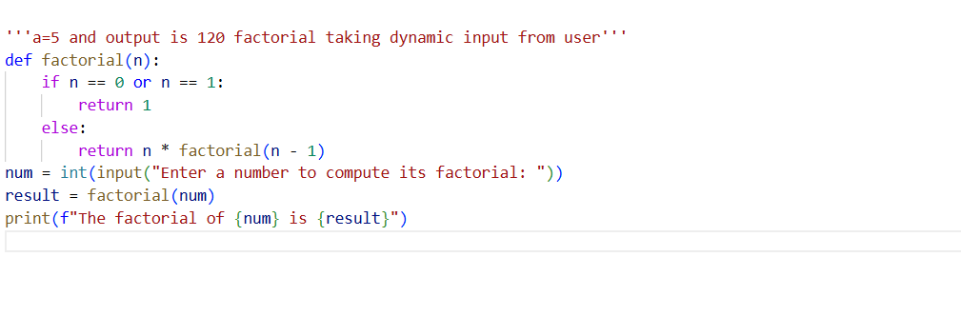
Task3
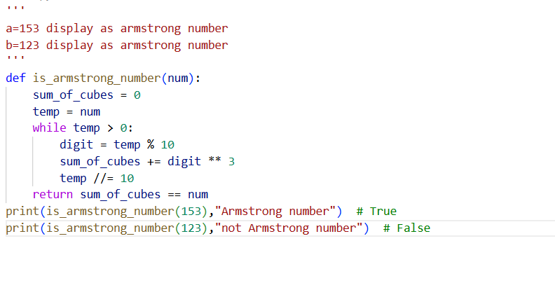
TASK4
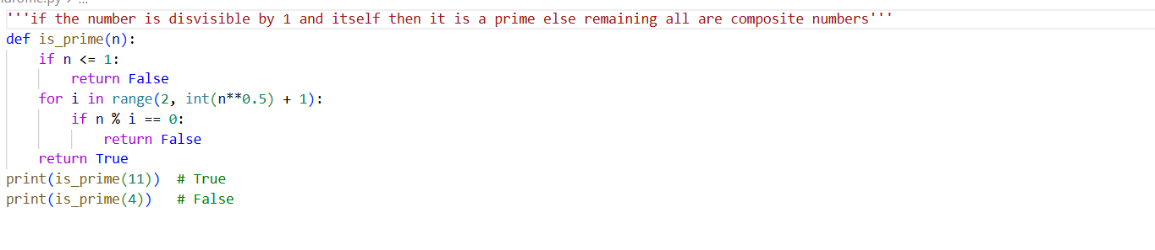
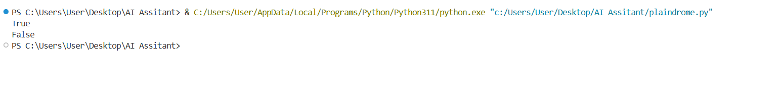
Task5
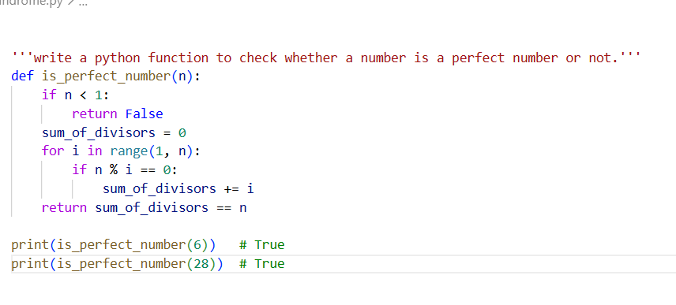
Task6
